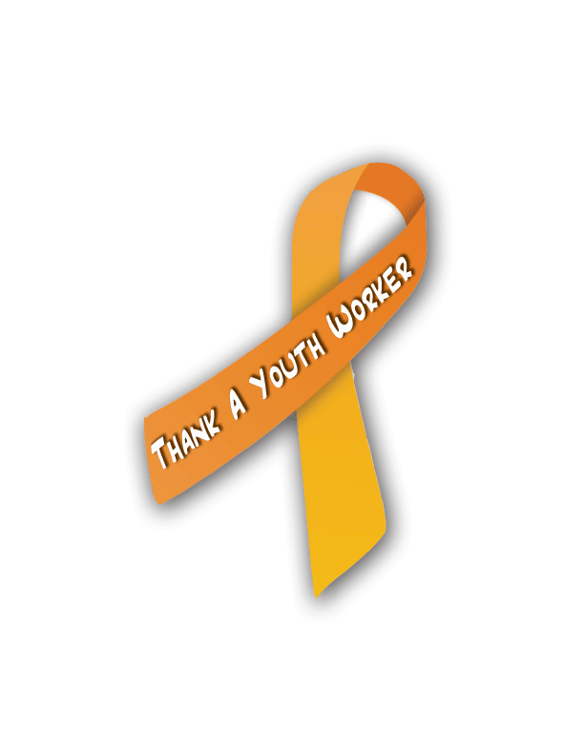
Thank a Youth
Worker Day

www.thankayouthworkerday.org

Newsletter Example

Thank a Youth Worker
According to the National Collaboration for Youth, a youth worker is an individual who works with or on behalf of youth to facilitate their personal, social, and educational development and enable them to gain a voice, influence, and place in society as they make the transition from dependence to independence. Sadly their work is so deeply embedded in the community that it can go unnoticed.
Let’s change that! On <DATE>, communities, organizations, and caring people around the globe will join together for a day of celebrating and honoring youth workers called Thank a Youth Worker Day. According to Brian Durand, co-chair of the Thank a Youth Worker Day Committee, “Everyone can point to a youth worker who had an impact in their life. Let’s thank those who mentor our youth and celebrate their contributions to our communities.”
Join the celebration by bringing Thank a Youth Worker Day to your area. Find tools to host an event at www.thankayouthworkerday.org. And please consider taking a moment to call, write, or personally give a word of thanks to youth workers you know who are such invaluable assets to our society. Our youth workers will thank you for it, and so will our children!

