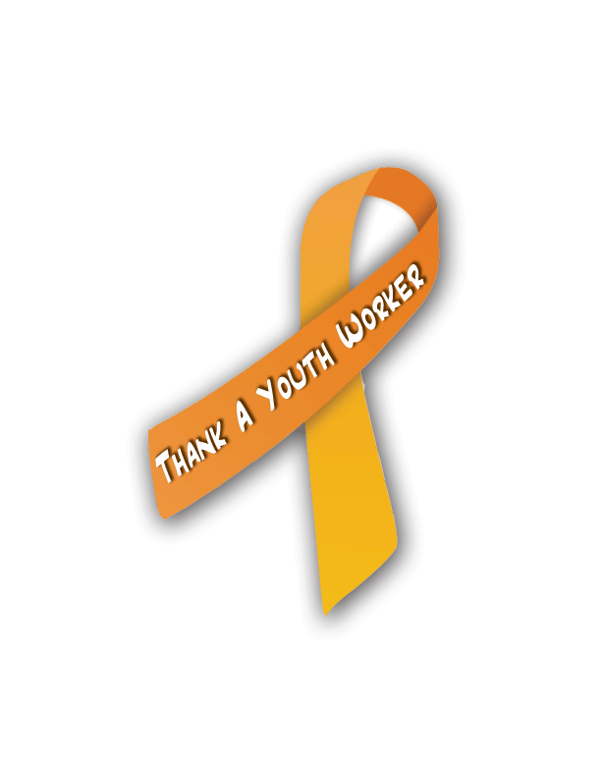
Thank a Youth
Worker Day

www.thankayouthworkerday.org

Sample Media Release

For Immediate Release
Contact: <Your name, email, and phone>

<OFFICIAL/COMMUNITY/ETC.> TO HONOR LOCAL YOUTH WORKERS

<Your city/state, date> On <DATE>, communities, organizations, and caring people from around the globe will join together for an international day of celebrating and honoring youth workers. Governments are making official proclamations, networks and organizations are holding celebrations, and leaders and other individuals are taking time out to call, write and personally say “thank you” to youth workers who are such a valuable and often unsung force in their communities.

(Add a line here about what is happening locally.)

According to the National Collaboration for Youth, a youth worker is an individual who works with or on behalf of youth to facilitate their personal, social and educational development and enable them to gain a voice, influence and place in society as they make the transition from dependence to independence. Brian Durand, Co-Organizer of the Thank a Youth Worker Day Steering Committee, says, “Everyone can point to a youth worker who had an impact in their life, formally as part of a youth-serving organization or informally as a coach, mentor, or friend. We need to thank those who mentor our youth and celebrate their contributions to our communities.”

For more information about Thank a Youth Worker Day, please visit the TAYWD website at www.thankayouthworkerday.org, or contact Co-Organizer Brian Durand at info@thankayouthworkerday.org. For information on local efforts, call <Insert name and contact information>.

